SS8 Financial Report and Analysis

Saturday, July 17, 2021

8:48 PM

# READING 25. INVENTORIES

1. Distinguish between costs included in inventories and costs recognized as expenses in the period in which they are incurred
2. Describe different inventory valuation methods (cost formulas):

* 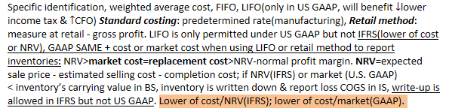

1. Calculate and compare cost of sales, gross profit, and ending inventory using different inventory valuation methods and using **perpetual** and **periodic** inventory systems

* 

1. Calculate and explain how inflation and deflation of inventory costs affect the financial statements and ratios of companies that use different inventory valuation methods
2. Explain LIFO reserve and LIFO liquidation and their effects on financial statements, ratios
3. Convert a company’s reported financial statements from LIFO to FIFO for purposes of comparison

LIFO 
Higher 
Lower 
Lower 
[ote: Assumes increasing prices and stable or increasing inventory levels. 
Cost of sales 
Ending inventory 
Gross profit 
FIFO 
Lower 
Higher 
Higher 

* 

1. Describe the measurement of inventory at the lower of cost and net realizable value
2. Describe implications of valuing inventory at NRV for financial statements and ratios

* 

1. Describe the financial statement presentation of and disclosures relating to inventories

* Disclosures in footnotes: inventory methods, total carrying value by classification = fair value - selling cost, COGS, inventory write-downs and reversals(IFRS only cuz GAAP Xallow)
  + Change in methods: Under IFRS, the firm must demonstrate that the change will provide reliable and more relevant information. Under U.S. GAAP, the firm must explain why the change in cost flow method is preferable. Exception-change to LIFO

1. Explain issues that analysts should consider when examining a company’s inventory disclosures and other sources of information
2. Calculate and compare ratios of companies, including companies that use different inventory methods
3. Analyze and compare the financial statements of companies, including companies that use different inventory methods

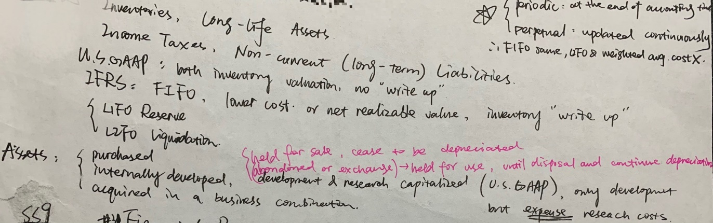

# READING 26. LONG-LIVED ASSETS

1. Distinguish between costs that are capitalized and costs that are expensed in the period in which they are incurred

* 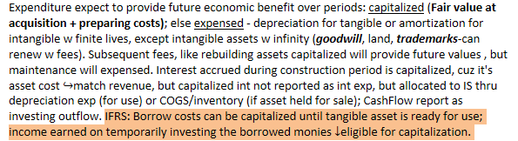

1. Compare intangible assets: purchased, internally developed, acquired in business combination

* **IFRS identifiable** intangible assets: can be separated from firm or from contractual legal right, controlled by firm, expected to provide future economic benefits[probable, measurable]. **Unidentifiable**: cannot be purchased separately with indefinite life, eg. Goodwill (purchase price - fair value of identifiable, net of liabilities acquired).
* 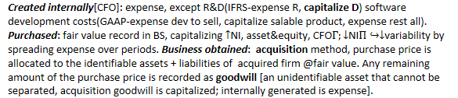

1. Explain and evaluate how capitalizing versus expensing costs in the period in which they are incurred affects financial statements and ratios

* 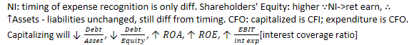

Total assets 
Shareholders' equity 
Income variability 
Net income (first year) 
Net income (subsequent years) 
Cash flow from operations 
Cash flow from investing 
Debt ratio & debt-to-equity 
Interest coverage (first year) 
Interest coverage (subsequent years) 
Capitalizing 
Higher 
Higher 
Lower 
Higher 
Lower 
Higher 
Lower 
Lower 
Higher 
Lower 
Expensing 
Lower 
Lower 
Higher 
Lower 
Higher 
Lower 
Higher 
Higher 
Lower 
Higher 

1. Describe the different depreciation methods for property, plant, and equipment and calculate depreciation expense

* Carrying (book) value = Historical cost[purchase price + delivery + installation, gross invest] - accumulated depreciation. Straight-line, accelerated, double-declining, units-of-production methods. IFRS requires **component depreciation**, while GAAP allows but rarely use.

1. Describe how the choice of depreciation method and assumptions concerning useful life and residual value affect depreciation expense, financial statements, and ratios
2. Describe different **amortization** methods for intangible assets with finite lives and calculate amortization expense: same above straight-line, accelerated DDB, check useful life time.
3. Describe how the choice of amortization method and assumptions concerning useful life and residual value affect amortization expense, financial statements, and ratios

Depreciation expense 
Net income 
Total assets 
Shareholders' equity 
Return on assets 
Return on equity 
Asset turnover ratios 
Cash flow 
Straight-Line 
Lower 
Higher 
Higher 
Higher 
Higher 
Higher 
Lower 
Same 
Accelerated 
Higher 
Lower 
Lower 
Lower 
Lower 
Lower 
Higher 
Same 

1. Describe the revaluation model

* 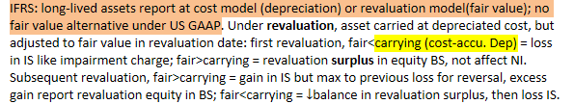

On December 31, 2()X1, Parsons Corp. reports a carrying value for an asset class as $30 million 
and a fair value of $29 million and reports a revaluation loss on the income statement of $1 million. 
On December 31, 20X2, Parsons determines that the fair market value of the asset class is $1.5 
million above its carrying value. This upward revaluation will be reported as a Sl million gain on 
the income statement (to reverse the previously recorded loss on the income statement) and a $0.5 
million increase in the revaluation surplus account that does not affect income, but increases equity 
directly. 
On December 31, 20X3, Parsons determines that the fair market value of the asset class is $1 
million below its carrying value. This loss first goes to reduce the existing revaluation surplus of 
$0.5 million, and the other $0.5 million of the downward revaluation is reported as a loss on the 

1. Explain the **impairment** of property, plant, and equipment and intangible assets

* IFRS: annual asses impairment=carrying(cost-accu. Dep) > **recoverable amount(Fair Value -selling cost or value in use[PV of CFs])**, or significant circumstances in market value change, write-down to recoverable[GAAP fair] on BS, impairment loss in IS limited reversal of write-up.
* US GAAP: only impairment when circumstances cannot recover carrying value, 1.recoverability test: carrying>future undiscounted CFs, 2.loss in IS measure=carrying-fair(or discounted PVCF).

The carrying value of the equipment is $900,000 original cost $100,000 accumulated depreciation 
= $800,000, and the recoverable amount under IFRS is $785,000 (greater of $785,000 value in use 
and $760,000 fair value less selling costs). Under IFRS, the asset is written down on the balance 
sheet to the $785,000 recoverable amount, and a $15,000 loss ($800,000 carrying value — $785,000 
recoverable amount) is recognized in the income statement. 
Under U.S. GAAP, the asset is impaired because the $795,000 expected future cash flows is less 
than the $800,000 carrying value. The asset is written down on the balance sheet to its $790,000 
fair value, and a $10,000 loss ($800,000 carrying value — $790,000 fair value) is recognized on the 

* 

1. Explain the derecognition of property, plant, and equipment and intangible assets

* When sold, gain/loss = actual selling price - carrying[original cost - accu. Dep - impair] in IS, CFI. When exchanged for other asset, carrying BV of exchanged=fair value if cannot truly estimated.

1. Explain and evaluate how impairment, revaluation, and derecognition of property, plant, and equipment and intangible assets affect financial statements and ratios

* 

1. Describe the financial statement presentation of and disclosures relating to property, plant, and equipment and intangible assets

* IFRS disclosures: o Basis for measurement (usually historical cost).
  + Useful lives[not required by GAAP] or depreciation rate.
  + Gross carrying value and accumulated depreciation.
  + Reconciliation of carrying amounts from beginning to end.
  + Title restrictions and assets pledged as collateral.
  + Agreements to acquire PP&E in the future(eg. Agreement to construction contract other).
    - Revaluation (fair value) model is used: date, how fair value decided, carrying value
  + Intangible assets w finite or indefinite lives
  + Amount of impairment losses and reversal by asset class.
  + Where losses and loss reversals recognized in IS.
  + Circumstances that cause the impairment loss or reversal.
* US GAAP disclosures:
  + Depreciation methods and expense by period.
  + Accumulated depreciation by major classes or in total.
  + Balances classes by nature and function i.e. land, improvements, machinery, furniture.
  + Intangible assets of estimate amortized expense for the next **5** years.
  + A description of the impaired asset and amount of loss.
  + Circumstances that caused the impairment.
  + How fair value was determined.
  + Where the loss is recognized in the income statement.

1. Analyze and interpret financial statement disclosures regarding property, plant, and equipment and intangible assets

* 

1. Compare financial reporting of investment property with that of property, plant, & equipment

* 

Transfer 
From 
Owner- 
occupied 
Inventory 
Investment 
property 
Transfer To 
Investment property 
Investment property 
Owner-occupied or 
inventory 
Financial Statement Treatment 
Treat as revaluation: recognize gain only if it reverses 
previously recognized loss 
Recognize gain or loss if fair value is different from 
carrying amount 
Fair value Of asset at date Of transfer will be its cost under 
new classification 

ملك١٠٠١١/١٥)- 
لمد) 
م ومهمهمل بي سا له رهماا 48مت 
مدع -٥: - امسإرعدن عمهرهور) 
بامم. -إرر 
ملمده :مامه سهبررمدهمم،،محه مهوععه طهم؟هيههته.مسهبر 
مو ها؟ 
امههه مهه ظمات مده ت . لمهدرحطعه سحمه7إتمومة» صسعه 
rvwft %-%Vati YPl.MüLeO-•T 
0 معاطهدنوهمهre؟ 
حصة7Pا3 
@ ييد.A 
,Q عسحنالم؟ يعوم c(ölpYYl%og حدد، (G. تصساو 
٩ ).Ohmme -t؟ 
صلد هـممهa60 
معادمهرهوم@ اهم 
٥٠١١ -ك إo) ٥ 

# READING 27. INCOME TAXES

1. Describe the differences between accounting profit and taxable income and define key terms, including **deferred tax assets, deferred tax liabilities**, valuation allowance, taxes payable, and income tax expense

* 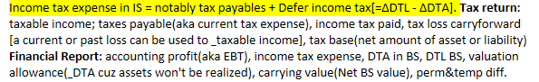

1. Explain how deferred tax liabilities and assets are created and the factors that determine how a company’s deferred tax liabilities and assets should be treated for purposes of financial analysis
2. Calculate the tax base of a company’s assets and liabilities

* 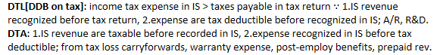

1. 
2. Evaluate the effect of tax rate changes on a company’s financial statements and ratios

A firm purchases equipment for $24,000 that has a three-year useful life. The firm depreciates the 
equipment using the straight-line method for financial reporting and double-declining balance for 
tax reporting. The tax rate is 40% in the first year, but in the second year, the expected tax rate 
decreases to 35%. Calculate the deferred tax liability in each year of the asset's life. 
Answer: 
The carrying value and tax base of the asset are shown in the following table: 
Straight-line depreciation 
Carrying value 
DDB depreciation 
Tax base 
Carrying value minus tax base 
Year 1 
$8,000 
516,000 
S16,ooo 
ss,ooo 
$8,000 
Year 2 
$8,000 
$8,000 
$5,333 
$2,667 
$5,333 
Year 3 
,ooo 
$2,667 
The deferred tax liability is equal to the expected tax rate times the difference between the carrying 
value and the tax base. In Year 1, the expected tax rate was 40% and the DTL was 40% x $8,000 = 
$3,200. In Year 2, the expected tax rate changed to 35% and the DTL was 35% x $5,333 $1,867. 

1. Distinguish between temporary and permanent differences in pre-tax accounting income and taxable income

* 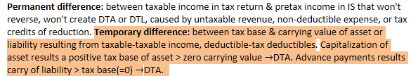

1. 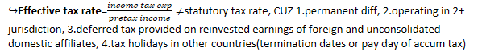
2. Describe the valuation allowance for deferred tax assets—when it is required and what effect it has on financial statements

* 

1. Explain recognition and measurement of current and deferred tax items
2. Analyze **disclosures** relating to deferred tax items and the effective tax rate reconciliation and explain how information included in these disclosures affects a company’s financial statements and financial ratios

* DTL results from using accelerated depreciation for tax purposes and normal for financial
* Impairments resulting in DTA, cuz write-down is immediate but tax deduction will wait till sold.
* Restructuring generates DTA, cuz costs recognized for financial but not tax deductible until paid. Note significant cash outflows(net of tax savings) in the years after restructuring costs report.
* 
* Post-employment benefits, deferred compensation: DTA reversing to tax deductible until paid.
* Available-for-sale marketable securities of unrealized gain/loss reflect on shareholders' equity: DTL
* Unrecognized DTL for undistributed earnings of subsidiaries and joint ventures
* Current-year tax effect of each type of temporary difference
* Reconciliation of reported income tax expense and tax expense based on statutory rate
* Tax loss carryforwards and credits

1. Identify the key provisions of and differences between income tax accounting under International Financial Reporting Standards (IFRS) and US generally accepted accounting principles (GAAP)

|  |  |  |
| --- | --- | --- |
| *Tax Accounting Differences* | U.S. GAAP | IFRS |
| **Revaluation** of fixed assets and intangible assets | Not applicable, no revaluation allowed. | Deferred taxes are recognized in **equity**. (Only the portion of the difference between the tax base and the carrying amount that is not the result of the revaluation is recognized as giving rise to a deferred tax liability. The portion arising from the revaluation surplus is used to reduce the revaluation surplus in equity.) |
| Undistributed profit from an investment in subsidiary | No deferred taxes for foreign subsidiaries that meet the indefinite reversal criterion.    No deferred taxes for domestic subsidiaries if the amounts are tax free. | Deferred taxes are recognized unless the parent is able to control the distribution of profit and it is probable the temporary difference will not reverse in the future. |
| Undistributed profit from an investment in a joint venture (JV) | No deferred taxes for foreign corporate JVs that meet the indefinite reversal criterion. | Deferred taxes are recognized unless the venturer is able to control the sharing of profit and it is probable the temporary difference will not reverse in the future. |
| **Undistributed profit from an investment** in an **associate** firm | Deferred taxes are recognized from temporary differences. | Deferred taxes are recognized unless the investor is able to control the sharing of profit and it is probable the temporary difference will not reverse in the future. |
| DTA recognition  (Deferred tax asset) | Recognized in full and then reduced if “more likely than not” <50% that some or all of the tax asset won't be realized. | Recognized if “probable” that sufficient taxable profit will be available to recover the tax asset. |
| Tax rate used to measure deferred taxes | Enacted tax rate only. | Enacted or substantively enacted tax rate. |
| Presentation of deferred taxes on the balance sheet | Classified as current or noncurrent based on the classification of the underlying asset or liability. | Classified as noncurrent. |

# READING 28.NON-CURRENT (LONG-TERM) LIABILITIES

1. Determine the initial recognition, initial measurement and subsequent measurement of bonds
2. Describe the effective interest method and calculate interest expense, amortization of bond discounts/premiums, and interest payments

* 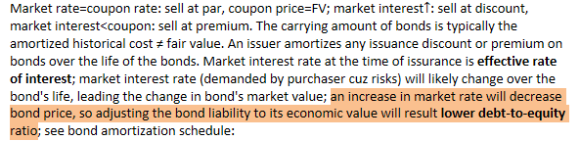

Interest expense each year is equal to market interest rate at issuance times the book value of the 
liability at the beginning of the year. Because the bond does not pay cash coupon interest, the entire 
amount of interest expense amortizes the discount. 
20X2 
20X3 
(l) Beginning 
Book Value 
$711.78 
797.19 
892.85 
(2) Interest 
Expense 
(1) x 12% 
$85.41 
95.66 
107.15 
(3) Ending 
BOOk value 
$797.19 
892.85 
1,000.00 

* Zero-coupon bond (aka pure-discount) makes no periodic interest payments. 3yr, YTM=12%, with a par value of $1,000; calculate interest expense and BV using effective interest method?

Interest expense reported in IS = market*BV of bond BS liability; but interest rate and book value of bond liability are calculated using bond's yield at issue time, not current yield. At any point in time, BV of bond liability=PV of remaining future cash flows (coupon pmt & face value).

1. Explain the **derecognition** of debt

* **Issuance costs**: initial bond liability reduced by legal accounting fees, printing costs, commission; are treated as unamortized discount on BS, but net against bond proceeds cash inflows as CFF under IFRS, GAAP more flexible.
* **Redeem** before maturity cuz low interest rate: a gain/loss recognized in continuing operations IS = BV of bond liability - redemption price at reacquisition date; CFF.

1. Describe the role of **debt covenants** in protecting creditors

* 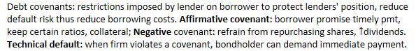

1. Describe the financial statement presentation of and disclosures relating to debt
2. Explain motivations for leasing assets instead of purchasing them

* 
* **Operating lease**: rental arrangement, A/L not reported by lessee, periodic lease=rental expense.

1. Explain the financial reporting of leases from a **lessee’s** perspective: **IFRS same from 2019**

Assets 
Liabilities (current and long-term) 
Net income (in the early years) 
Net income (later years) 
Total net income 
EBIT (operating income) 
Cash flow from operations 
Cash flow from financing 
Total cash flow 
Finance Lease 
Higher 
Higher 
Lower 
Higher 
Same 
Higher 
Higher 
Lower 
Operating Lease 
Lower 
Lower 
Higher 
Lower 
Same 
Lower 
Lower 
Higher 
Same 

Current ratio (CA / CL) 
Working capital (CA — CL) 
Asset turnover (revenue I TA) 
Return on assets* (NI / TA) 
Return on equity* (NI / SE) 
Debt / assets 
Debt / 
Lower 
Lower 
Lower 
Lower 
Lower 
Higher 
Higher 
Higher 
Higher 
Higher 
Higher 
Higher 
Lower 

1. Explain the financial reporting of leases from a lessor’s perspective - chapter+p224

* Under IFRS, **finance lease**: “transfers substantially all the risks and rewards incidental to ownership of an underlying asset”, lessor derecognizes the underlying leased asset, and recognizes a lease receivable, and recognizes selling profit where applicable. **Operating leases**: lessor derecognizes underlying asset and recognizes lease receipts as income&BS lease invest/R.
* Under US GAAP, a lessor classifies a finance lease in one of three categories: **sales-type**(PV of lease payment>carrying value), **direct financing**(PV pmt=carrying), or **operating**; IFRS x diff. The lessor’s classification and accounting for operating leases under US GAAP is similar to that under IFRS. For both sales-type and direct financing leases, the lessor derecognizes the underlying asset and recognizes a lease receivable; however, the lessor recognizes selling profit only if the lease is considered a sales-type lease. For **lessee** accounting, the distinction between finance leases and operating leases exists in US GAAP but not in IFRS.
* Operating lease is an off-balance-sheet, cuz appear neither in A nor L. Adjustment for operating leases is to treat them as capital leases by estimating present value of future lease obligations and adding that value to the firm’s liabilities and long-lived assets. In finance lease, inception of lease is lower of PV of future min lease pmt or fair value of leased asset; interest rate used by lessee is lower of incremental borrowing rate or lessor's implicit rate; interest CFO, principal CFF

1. Compare presentation and disclosure of defined contribution and defined benefit pension plans

* Under both IFRS and US GAAP, companies must report the difference between the defined benefit pension obligation and the pension assets as an asset or liability on the balance sheet. An **underfunded** (fair value of plan's asset > estimated pension obligation) defined benefit pension plan is shown as a non-current net pension liability. **Defined contribution plan**: amount of contribution into the plan is specified (i.e., defined) and the amount of pension that is ultimately paid by the) plan (received by the retiree depends on the performance of the plan’s assets, payment record as pension expense. **Defined benefit plan**: amount of pension ultimately paid by the plan (received by the retiree) is defined to a formula; actuarial gain/loss report as OCmpInc in BS and interest expense accrued on begin net pension obligation is profit/loss in IS.

1. Calculate and interpret leverage and coverage ratios

When evaluating solvency, accounts payable and accrued liabilities aren't considered debt, only calculate interest bear obligation: notes payable, LT debt. Fixed charge coverage refers to ratios.







